ANSWERS
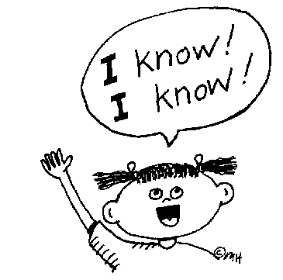
Check your own answers on this page!
How well did you do?
What did you find easy?
What do you need to practise more?

PAGE 1
Activity 1 – cincuenta 50, trece 13, ochenta 80, noventa 90, cuatro 4, setenta 70, once 11, treinta 30, veintiuno 21, catorce 14, cien 100
Activity 2 – 18 in red; 56 in pink; 89 in yellow; 94 in green; 77 in blue; 42 in orange
Activity 3 – what is your name, my name is, thank you, you’re welcome, please, see you later, goodbye, yes, I am from, I’m 12 years old, I live in, with, on/in, at/to
Activity 4 – 1h, 2d, 3j, 4m, 5n, 6l, 7k, 8i, 9g, 10a, 11b, 12f, 13e, 14c

PAGE 2
Activity 5 – coméis, compran, bailas, bebo, visita, recibe, escriben, baila, comemos, bebe, visitan, escribimos, comes, visitáis, comen, bailamos, bebes, viajan, escribís, bailo, bebe, come, compramos, visito, escribe, hablan
Activity 6 – I play, you are, I do, he/she has, they don’t have, they play, I go, I am, there is, he/she/it is, I don’t do, he/she/it is not, I have, they go
Activity 7 – 1h, 2c, 3a, 4k, 5b, 6n, 7g, 8j, 9l, 10f, 11e, 12i, 13d, 14m

PAGE 3
Activity 8a – 1b, 2g, 3e, 4i, 5a, 6d, 7h, 8f, 9j, 10c
Activity 8b – I’m going to go to France; We’re going to live in Ireland; They’re going to play football; You’re going to visit the monuments; He’s going to go to the USA; You (pl.) are going to play the guitar.
Activity 8c – comer, a, va, hacer, visitar, vas
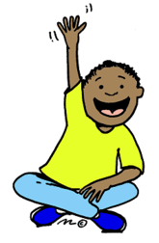
Activity 8d – Voy a ir; vamos a comer; van a visitar; va a ir; vamos a beber; vais a bailar; vas a hacer, vamos a jugar

PAGE 4
Activity 9 – sin embargo – however, pero – but, porque – because, aunque – although, también – also
Activity 10 – it’s sunny, it’s hot, it’s cold, it’s raining, it’s cloudy, it’s snowing, it’s stormy, it’s windy
Activity 11 – very, more, too (much), when, where, that, no-one, for, of, in/on
Activity 12 – 1h, 2o, 3a, 4m, 5c, 6j, 7d, 8b, 9t, 10f, 11g, 12e, 13k, 14p, 15r, 16l, 17i, 18n, 19q, 20s

PAGE 5
Activity 13 – padre, hermano, hermana, abuela, abuelo, primo, tía, tío, hermanastro, hermanastra, amigo, perro, gato, caballo, conejo, pez
Activity 14 – soy – I am, tiene – he/she has, es – he/she is, tengo – I have, tenemos – we have, puede ser – he/she can be, me gusta – I like, me gustaría - I would like, me encanta – I love, odio – I hate
Activity 15 – pelo, ojos, gafas, negro, rubio, castaño, largo, corto, alto, bajo, gordo, delgado
Activity 16 – 1e, 2l, 3a, 4q, 5t, 6b, 7c, 8n, 9d, 10f, 11h, 12i, 13s, 14g, 15r, 16j, 17p, 18k, 19o, 20m

PAGE 6
Activity 17 – football, basketball, tennis, athletics, cycling, skiing, jogging, horse-riding, gymnastics, sailing, skating, boxing, dancing, climbing, skateboarding
Activity 18 – A11, B1, C6, D12, E9, F4, G3, H2, I7, J5, K8, L10
Activity 19 – practico, practicas, practica, practicamos, practicáis, practican; juego, juegas, juega, jugamos, jugáis, juegan; hago, haces, hace, hacemos, hacéis, hacen
Activity 20 – 1h, 2e, 3g, 4a, 5k, 6b, 7c, 8l, 9d, 10i, 11j, 12f

PAGE 7
Activity 21 – como, comes, come, comemos, coméis, comen; desayuno, desayunas, desayuna, desayunamos, desayunáis, desayunan.
Activity 22 – A) 1P, 2N, 3N, 4N, 5P, 6N, 7P, 8P, 9P, 10N, 11N, 12P, 13P, 14P
B) asqueroso, sana, ricos, aburridas
Activity 23 – 1n, 2u, 3b, 4a, 5m, 6s, 7d, 8r, 9g, 10w, 11e, 12dd, 13y, 14bb, 15dd, 16z, 17h, 18aa, 19j, 20k, 21v, 22c, 23p, 24l, 25f, 26x, 27t, 28i, 29q, 30o

