GCSE MFL @ Hounsdown
A PARENT’S GUIDE

The New AQA GCSE
There will be four exams at the end of Year 11 – a reading, a listening, a speaking and a writing exam. Students will be entered for either Foundation or Higher tier.

There are three main topic areas we will be covering:
Theme 1: Identity and culture
Me, my family and friends – marriage and relationships
Technology in everyday life – social media/mobile technology
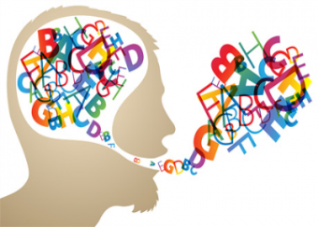
Free-time activities – music, cinema and TV, food/eating out/ sport
Customs and festivals

Theme 2: Local, national, international and global areas of interest
Home, town, neighbourhood and region
Social issues – charity/voluntary work, healthy and unhealthy living
Global issues – the environment, poverty, homelessness
Travel and tourism

Theme 3: Current and future
My studies
Life at school/college
Education post-16
Jobs, career choices and ambitions

5 Ways Parents Can Help
1. Memrise: Encourage your son/daughter to go on Memrise.com (vocabulary learning website) regularly. I recommend at least half an hour a week. Ideally students should have completed two of the courses on here before the end of Year 9. There will then be three courses left to complete in Years 10 and 11. The more vocabulary they know, the easier the final exams should be for them.
2. GCSE Survival Kit: Encourage your son/daughter to work through the Survival Kit (vocabulary booklet) and translate the vocabulary. When they know a word/phrase off by heart they could highlight it. You could then help by reading out the words and asking them to translate them from memory.
3. After School Intervention: Encourage your son/daughter to attend the fortnightly after school intervention sessions with Ms Holgate. Students know whether they should be attending the Foundation or Higher sessions.
4. Tenses Revision: Encourage your son/daughter to attend Mrs Warren’s lunchtime sessions (see attached timetable) after half term. Students should attend the sessions of the tenses they need more practice on.
5. FROG: If your son/daughter needs further practice on tenses there are lots of revision pages, including quizzes on FROG. Just type the language and the tense into the search bar.

