STARTER ACTIVITY:
How many ‘holidays’ words can you think of?
Write these in the suitcase below in English (or Spanish if you know how!)
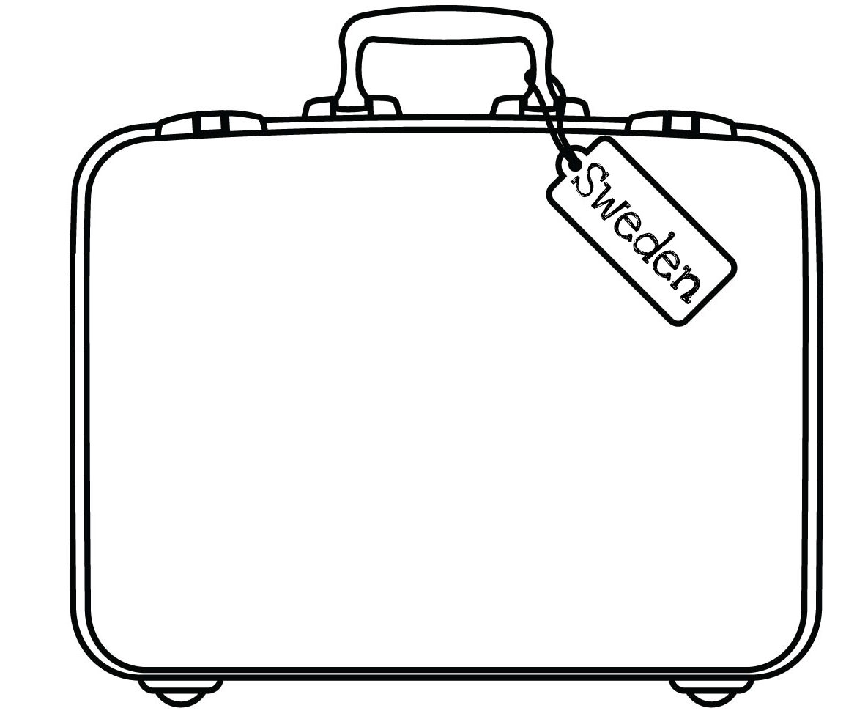
Ideas: countries, holiday activities, transport, places, holiday items…

