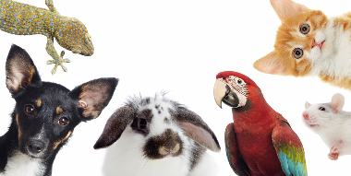
Me llamo _______________________
LAS MASCOTAS – TRADUCIR
Pets - Translation
I have a dog who is called Holly and a cat who is called Fluffy.
T | u | p | q | s
l | H | y | u | g
q | s | l | F
I have two fish* who are called Bob and Jim.
T | d | p | q | s
l | B | y | J
I have a tarantula who is called Sam and a bird who is called Mary.
T | u | a | q | s
l | S | y | u | p
q | s | l | M
My best friend has a dog who is called Luna and a rabbit who is called Colin.
M | m | a | t | u
p | q | s | l | L
y | u | c | q | s
l | C
My sister has a mouse who is called Squeak.
M | h | t | u | r
q | s | l | S
When I was little I used to have a goldfish, who was called Nemo, but unfortunately he died.
C | e | p | t
u | p | q | s
l | N | p | d
m
When I am older I would like to have a tortoise who is called Brian.
C | s | m | m
g | t | u | t
q | s | l | B
Extension Challenge: Can you translate the following without the first letters to help you?
I have a cat who is called Luigi. I love my cat because he’s cute. When I was little I used to have a snake, who was called Martin, but unfortunately he died. When I am older I would like to have a hamster who is called Fudge.

