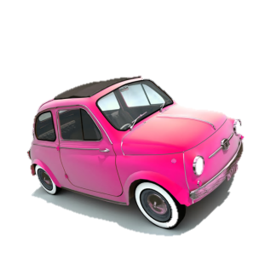Me llamo _______________

Mis Vacaciones – My Holidays

**Translate these sentences into Spanish. Use your vocabulary sheets to help you.**

1. Normally I go London with my family because it’s interesting. I prefer to travel by train because it’s cheap.

|  |  |  |  |
| --- | --- | --- | --- |
| N | v | a | L |
| c | m | f | p |
| e | i | P | v |
| e | t | p | e |
| b |

1. Sometimes I go to Scotland with my parents because it’s fun. I prefer to travel by car because it’s clean.

|  |  |  |  |
| --- | --- | --- | --- |
| A | v | v | a |
| E | c | m | p |
| p | e | d | P |
| v | e | c | p |
| e | l |

1. I always (*Always I go to*) go to France with my mum because it’s fascinating. I prefer to travel by ferry because it’s fun.

|  |  |  |  |
| --- | --- | --- | --- |
| S | v | a | F |
| c | m | m | p |
| e | f | P | v |
| e | f | p | e |
| C:\Users\Danni\AppData\Local\Microsoft\Windows\Temporary Internet Files\Content.IE5\GN3R2XBJ\MC900089376[1].wmfd |

1. Each year I go to Spain with my grandparents because it’s interesting. I prefer to travel by plane because it’s quicker (*more quick).*

|  |  |  |  |  |
| --- | --- | --- | --- | --- |
| C | a | v | a | |
| E | c | m | a | |
| p | e | i | P | |
| v | e | a | p | |
| e | m | r | |

1. Often I go to Italy with my friends because it’s fascinating. I prefer to travel by plane because it’s fun.

|  |  |  |  |
| --- | --- | --- | --- |
| A | m | v | a |
| I | c | m | a |
| p | e | f | P |
| v | e | a | p |
| e | d |

**Extension:**

1. **Improve each of these sentences adding however (sin embargo), but (pero) or although (aunque).** *E.g….sin embargo es caro – however it’s expensive.*
2. C:\Users\Danni\AppData\Local\Microsoft\Windows\Temporary Internet Files\Content.IE5\SGUWNCCM\MC900415748[1].wmf**Produce some similar sentences at the front of your yellow book. Remember to write the date at title in Spanish first.**