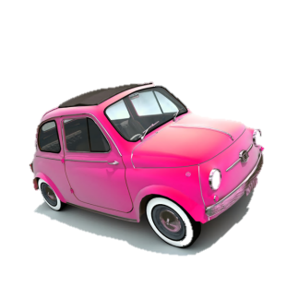Me llamo _______________

Mis Vacaciones – My Holidays

**Translate these sentences into Spanish. Use your vocabulary sheets to help you.**

1. Normally I go London with my family because it’s interesting. I prefer to travel by train because it’s cheap.

|  |  |  |  |
| --- | --- | --- | --- |
|  |  |  |  |
|  |  |  |  |
|  |  |  |  |
|  |  |  |  |
|  |

1. Sometimes I go to Scotland with my parents because it’s fun. I prefer to travel by car because it’s clean.

|  |  |  |  |
| --- | --- | --- | --- |
|  |  |  |  |
|  |  |  |  |
|  |  |  |  |
|  |  |  |  |
|  |  |

1. I always (*Always I go to*) go to France with my mum because it’s fascinating. I prefer to travel by ferry because it’s fun.

|  |  |  |  |
| --- | --- | --- | --- |
|  |  |  |  |
|  |  |  |  |
|  |  |  |  |
|  |  |  |  |
| C:\Users\Danni\AppData\Local\Microsoft\Windows\Temporary Internet Files\Content.IE5\GN3R2XBJ\MC900089376[1].wmf |

1. Each year I go to Spain with my grandparents because it’s interesting. I prefer to travel by plane because it’s quicker (*more quick).*

|  |  |  |  |  |
| --- | --- | --- | --- | --- |
|  |  |  |  | |
|  |  |  |  | |
|  |  |  |  | |
|  |  |  |  | |
|  |  |  | |

1. Often I go to Italy with my friends because it’s fascinating. I prefer to travel by plane because it’s fun.

|  |  |  |  |
| --- | --- | --- | --- |
|  |  |  |  |
|  |  |  |  |
|  |  |  |  |
|  |  |  |  |
|  |  |

**Extension:**

1. **Improve each of these sentences adding however (sin embargo), but (pero) or although (aunque).** *E.g….sin embargo es caro – however it’s expensive.*
2. C:\Users\Danni\AppData\Local\Microsoft\Windows\Temporary Internet Files\Content.IE5\SGUWNCCM\MC900415748[1].wmf**Produce some similar sentences at the front of your yellow book. Remember to write the date at title in Spanish first.**