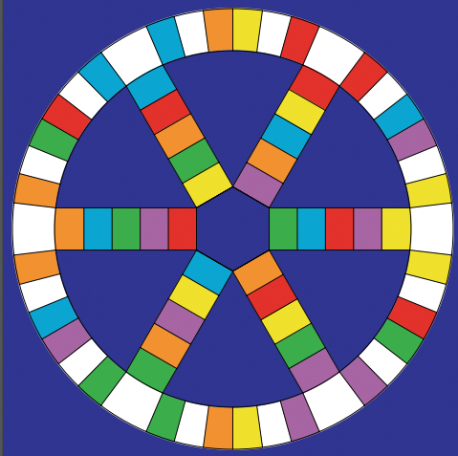

Rules
Take it in turns to roll the dice and move
your counter around the board.
Whichever colour you land on will be the
colour of the question you will answer on
the card.
Your teammates should ask the question.
When you land on a white square you
may choose your own topic.
If you answer a question correctly when
you are on a larger square, you may
shade in the correct segment on your
sheet.
The first person to reach the centre circle
with all 6 segments shaded in is the
winner.

Topics
bbbb
General Vocabulary
Verbs
Lifestyle
Leisure
Work & Education
Home & Environment

