MIS VACACIONES – MY HOLIDAYS
Use the vocabulary sheet to help you
ACTIVIDAD 1: Match up the time phrases below
Normalmente Often
Generalmente Sometimes
Siempre Each year
A menudo Normally
A veces Always
Cada año Generally
ACTIVIDAD 2: Fill in the gaps for these countries
Esc_ci_ – Scotland
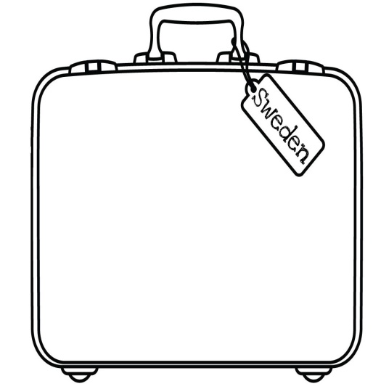
G_l_s – Wales
I_la_da – Ireland
E_pañ_ – Spain
Fr_ncia – France
Ale_ania – Germany
I_ali_ – Italy
Gre_ia – Greece
L_s Es_ados _nid_s – the USA

