The Immediate Future Tense
- Read through your notes carefully from last lesson
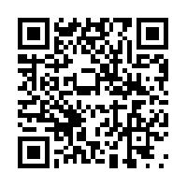
- Type in this link/scan the QR code and look at the video and information on my website
http://missmorgs.weebly.com/french/the-immediate-future-tense

- Now translate the sentences below into French

- Tonight I am going to play football with my brother.
_______________________________________________________________________________________________
- Tomorrow we are going to watch a film at the cinema.
_______________________________________________________________________________________________
- Next weekend she is going to go horse riding.
_______________________________________________________________________________________________
- Next week they are going to go swimming in the swimming pool.
_______________________________________________________________________________________________

The Immediate Future Tense
- Read through your notes carefully from last lesson
- Type in this link/scan the QR code and look at the video and information on my website
http://missmorgs.weebly.com/french/the-immediate-future-tense

- Now translate the sentences below into French

- Tonight I am going to play football with my brother.
_______________________________________________________________________________________________
- Tomorrow we are going to watch a film at the cinema.
_______________________________________________________________________________________________
- Next weekend she is going to go horse riding.
_______________________________________________________________________________________________
- Next week they are going to go swimming in the swimming pool.
_______________________________________________________________________________________________

