PATTERNS

RECOGNISING VOCABULARY

STRATEGIES

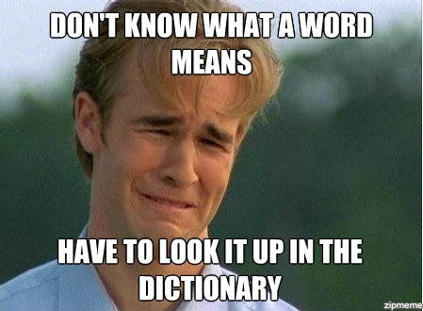

|  |  |
| --- | --- |
| **French** | **English** |
| -er / ir / re | begins with ‘to…’ (infinitive) |
| -é/i/u | -ed / -t |
| -ant | -ing |
| -ment | -ly |
| -eur | -our / -or / -er |
| é- | s- |
| -é / -e / -i | -y |
| -ique | -ic |
| -isme | -ism |

Is it a cognate?

Is there another word you recognise within the word?

Can you guess part of the word from the prefix or the suffix?

Is there a similar word you know in English or in another language?

Think about what type of word it is *ie. noun, verb, adjective*

Can you break the word down into smaller chunks?

Have you seen it anywhere else?