Nombre:______________________________

Trivial Pursuit
Shade in each of the segments when you answer a question correctly
(only the questions for the larger squares on the board)
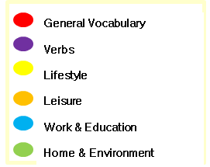

New vocabulary I have learnt:

The topic/s I have found the easiest are:
e.g. Leisure, in particular holiday vocabulary

The topic/s I have found the most difficult are:
e.g. Home and Envionment, in particular environmental issues vocabulary

To improve I will spend time…
Tick the things you’re going to do
completing the exercises on Memrise
playing the relevant games on Language Gym
reading the revision notes in the AQA Revision Guide
completing the exercises in the AQA Workbook
completing the crosswords on FROG
completing the ‘revision quickies’ sheets
Other: ____________________________________________________
__________________________________________________________

for this topic/these topics for __________ minutes a day/week.

